Sensor Tester - PC interface
REV 2.12 – 17.10.2013

Roni D.

Content Page
Interface demo image ……………………….. 2
Register map …………………………………. 3
Test string on status window ……………….. 4
Bench test ……………………………………. 6
Setting calibration constants ………………. 7
Serial communication ……………………… 8

Interface demo image
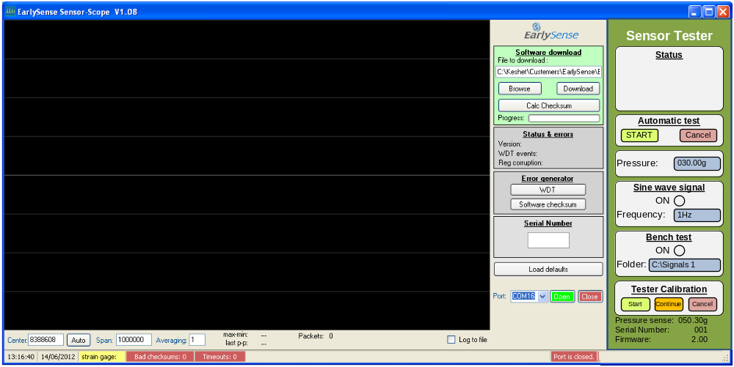

Register map
Sensor tester MCU memory map
Address | R/W | Bytes | Function | Remarks
$2000 | R | 2 | Firmware number | 16 bits. MSB first. Format is 0.00
$2002 | R | 1 | Serial number | 8 bits. Format 000
$2003 | R | 2 | Sense | 16 bits. Format “000.00g”
$2005 | R | 1 | Automatic test bar | Graphic progress bar. 0=Empty 255=Full
$2006 | R | 1 | Status string | See table below
$2007 | R/W | 2 | Frequency | 16 bits. Format “0.0Hz”
$2009 | R/W | 2 | Pressure | 16 bits. Format “000.00g”
$200B | W | 1 | Key press | Key code is set by the PC. Cleared by the sensor tester.  Code 00 – No operation  Code 01 – Automatic test “start” key  Code 02 – Automatic test “Cancel” key  Code 03 – Tester calibration “start” key  Code 04 – Tester calibration “Cancel” key  Code 05 - Tester calibration “Continue” key
$200C | R/W | 1 | Radio button  Manual operation | Manual operation radio button.  Status is always read from the sensor tester.  Code 00 – Disabled  Code 01 – Enabled
$200D | R/W | 1 | Radio button  Bench test | Manual operation radio button.  Status is always read from the sensor tester.  Code 00 – Disabled  Code 01 – Enabled
$200E | R | 1 | Buffer busy | Streaming data buffer busy / ready indication  0 = Ready 1 = Busy
$200F | R/W | 2 | Calibration constant | 16 bit number 0.001 per unit. Range 0.500 to 3.500 (Trim.)
$2011 | R/W | 2 | DAC constant | 16 bit number. 0.001 per unit. Range 0.500 to 3.500 (Trim.)
$2500 | W | 249 | Buffer 0 | Up to 124 samples can be written into this buffer.  Byte 0,1 – Sample 0 (MSB,LSB)  Byte 2,3 – Sample 1 (MSB,LSB)  …  Byte 246,247 – Sample 123 (MSB,LSB)  Byte 248 – Packet ID – 8 bits. Begin with 1. Modulo 255.

Test string on status window

The MSB (bit 7) defines the font color.
Bit 7 = 0 / Font color Black
Bit 7 = 1 / Font color Red

Text string is centered on the status window.

Code | Status text string | Demo image
From PC | Sensor tester  not found. | 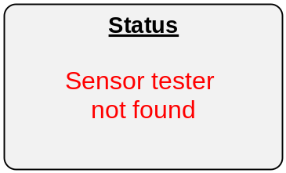
0 | Blank – No text | 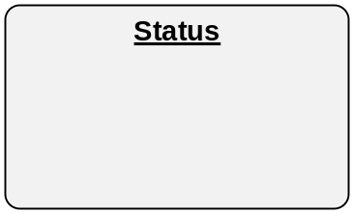
1 | Automatic test  in progress. | 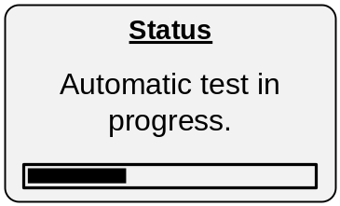
2 | Automatic test  completed. | 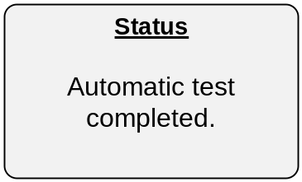
3 | Sine wave signal  is active. | 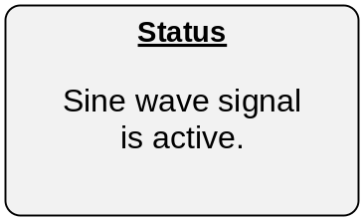
4 (+128) | Error on test!  Check sensor position,  and Re-start test | 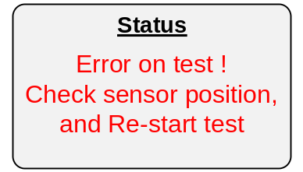
5 | Calibration step 1:  Place 40g  on sensing area  and press “continue” | 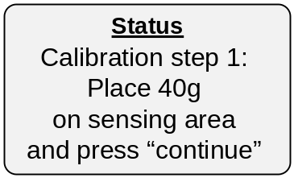
6 | Calibration step 2:  Place 40g+40g  on sensing area  and press “continue” | 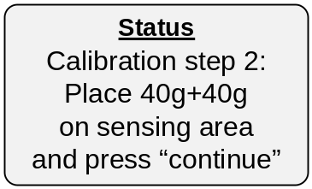
7 (+128) | Calibration not valid.  Process is canceled | 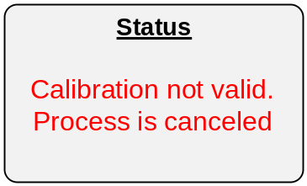
8 | Calibration completed successfully | 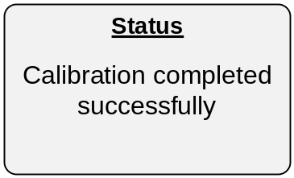
9 | Bench test in progress  [File name]  [File number / Total no. of files] | 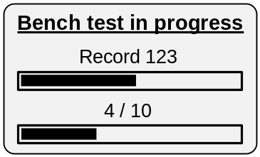
10 | Bench test completed | Status  Bench test completed

Bench test
Pressing the bench-test radio button will active the bench-test process.
The PC will stream sample data files, given at “Folder” box, into the sensor tester.
The file order is according to ABC order.

Data pre-streaming processing
The data in the signal file will be processed as following:
- The data value is divided by 10
- The average of the signal is subtracted from each value (Removing DC level)
- If the final value exceeds the range of -22500 to +22500 then an error message will pop-up “Signal amplitude is too high. Bench test stopped”
- The final result is streamed as a 16 bit integer, 2’th compliment value.

The samples will be grouped into 125 samples per packet, and sent to the sensor tester, via “Write block packet” (See communication on page 7)
The PC software pulls register “Buffer empty”, and sends the data packet whenever this register indicates “Ready” (zero).
Usually, the “Data length” parameter in the write block message (page 7) will be set to 125. However, if less than 125 samples remains to the end of the data file, then the “Data length” parameter will be set to the relevant value.

Streaming the next file
A 1.04 second delay will be initiated after streaming of a data file is completed. The next file will be streamed afterwards. The delay is implemented by streaming of silent data for approximately 1.04 second.

Status window during bench test
The status window will display the followings:
- Current file name being streamed
- Progress bar, indicating the streamed bytes relative to the file size
- Number of file being streamed and the total number of data files in the selected folder
- Progress bar, indicating the Number of file being streamed relative to the total number of data files in the selected folder.

Bench test termination
Bench test can be terminated by 2 scenarios:
- Pressing the relevant radio button.
- The last file in the folder has completed its streaming to the sensor tester. In this case, the sensor tester will turn the “Bench test” radio button automatically, and the PC software does not need to care for that.

Setting calibration constants
Pressing CTRL+SHIFT+C will open a password window:

Enter constants-calibration password:

The password value is “1000”
If wrong password is entered then do nothing.
If correct password is entered then open the following window:

Constant settings X

Calibration constant: 1.000

DAC constant: 1.000

Those values are read in real time from the tester (See table on page 3), and can be edited freely by the user. Window is closed when the “X” is pressed.
Note those parameter scale and ranges (See page 3).
Serial communication

General
The External system (such as PC terminal) master, and the micro-controller (known as target) will only “answer” to the master demands. In general, the control of the external devices (PC or hand-held) over the system is implemented by reading or writing strings, targeting addresses in the micro-controller memory map. Each address has a different functionality, like range setting, configuration, voltage monitoring, and others.

Communication specifications

Parameter | Value
Port | Serial COM port implemented by USB Bridge CP2102
USB identification | Serial number: 0002  Product string: EarlySense Sensor Tester
Protocol | RS232
Baud rate | 256000bps, 1 start bit, 1 stop bit
Packet | 15 bytes on packet. Read every 100ms.
Max. byte-to-byte interval from PC to Tester | 200ms.  A longer interval will be interpreted as a new command.
Tester reply delay | 30mSEC Max.
Max. byte-to-byte interval from Tester to PC | 0.1mSEC Max.

Reading parameter
Read string request packet
Byte 1: start byte code, with the value of ‘R’ (82)
Byte 2,3: 16bit address (msb first)
Byte 4: Data length (n = 1-255)
Byte 5: Normal 8 bit check sum (8 lsb)

Read string respond packet
Byte 1: start byte code, with the value of ‘R’ (82)
Byte 2…2+n: data bytes, according to the data length
Byte 3+n: Normal 8 bit check sum (8 lsb)

Writing parameter

Write byte packet
Byte 1: start byte code, with the value of ‘W’ (87)
Byte 2,3: 16bit address (msb first)
Byte 4: byte data
Byte 5: Normal 8 bit check sum (8 lsb)

Write acknowledge
Byte 1:Ack code ‘W’ (87) – must be monitored by PC before sending the next read/write command

Write block packet
Byte 1: start byte code, with the value of ‘B’ (66)
Byte 2,3: 16bit address (msb first)
Byte 4: Data length (n = 1-255)
Byte 5…5+n: Data bytes
Byte 6+n: Normal 8 bit check sum (8 lsb)

Block acknowledge
Byte 1:Ack code ‘W’ (87) – must be monitored by PC before sending the next read/write command

Check-sum error
Error code ‘E’ (69) will be received for check-sum error. Error code will not be transmitted if echo option is enable.

Packet time out error
If byte-to-byte interval is longer than 200mSEC, then the packet is ignored by the target. No “Ack” byte will be send.

Retry and data correction
Packet-sending retry, and data correction, are all at the responsibility of the master device.

